

NSS UNIT
TREE PLANTATION AT COLLEGE CAMPUS
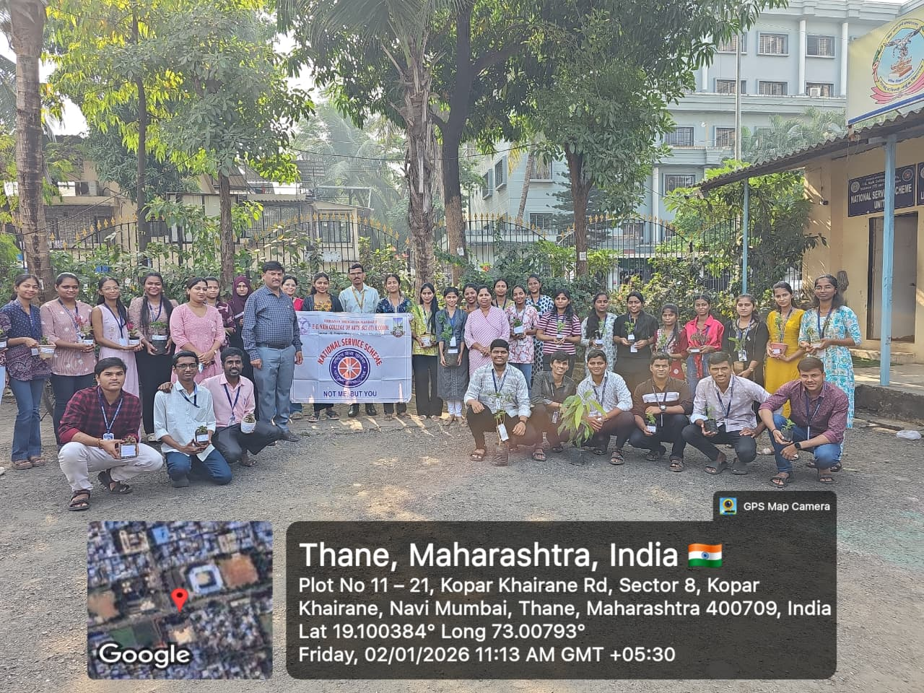

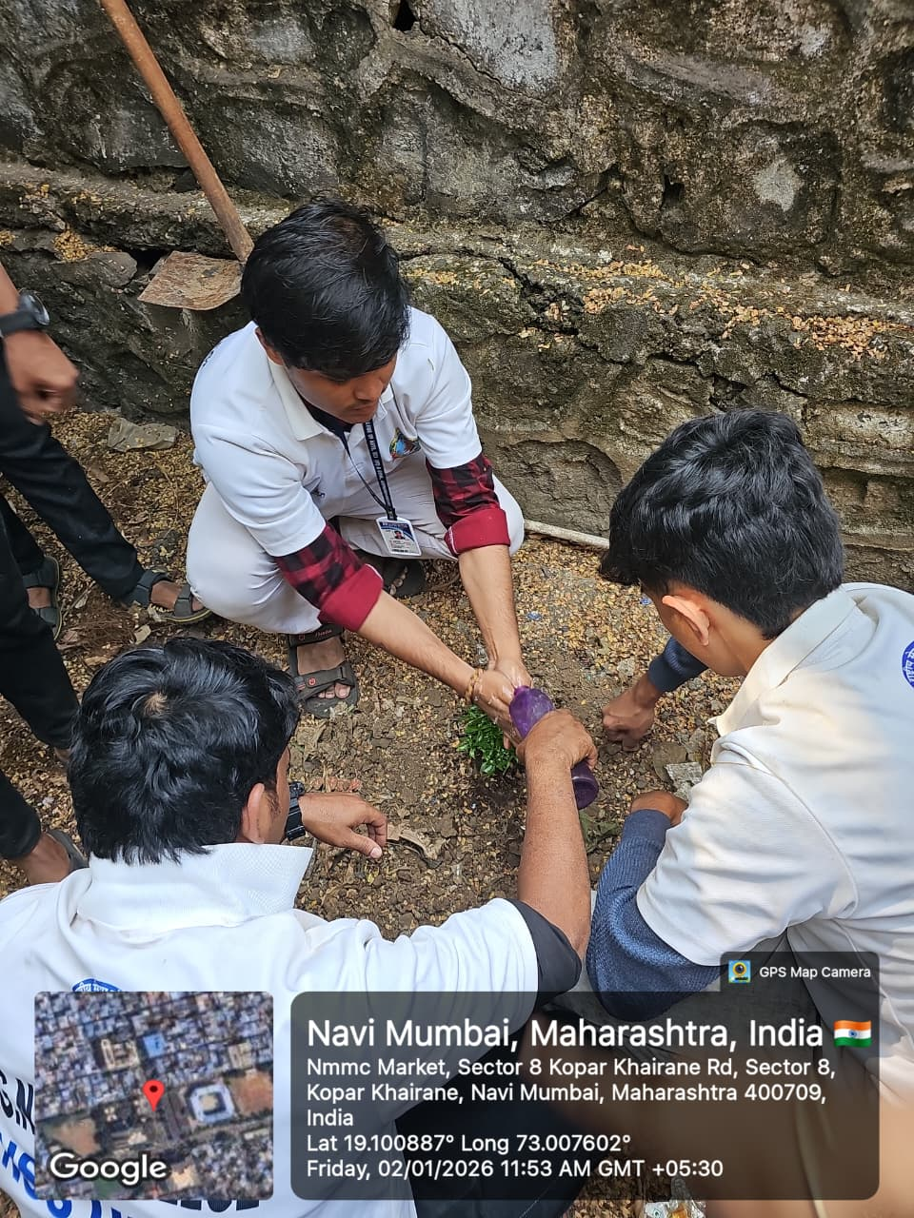
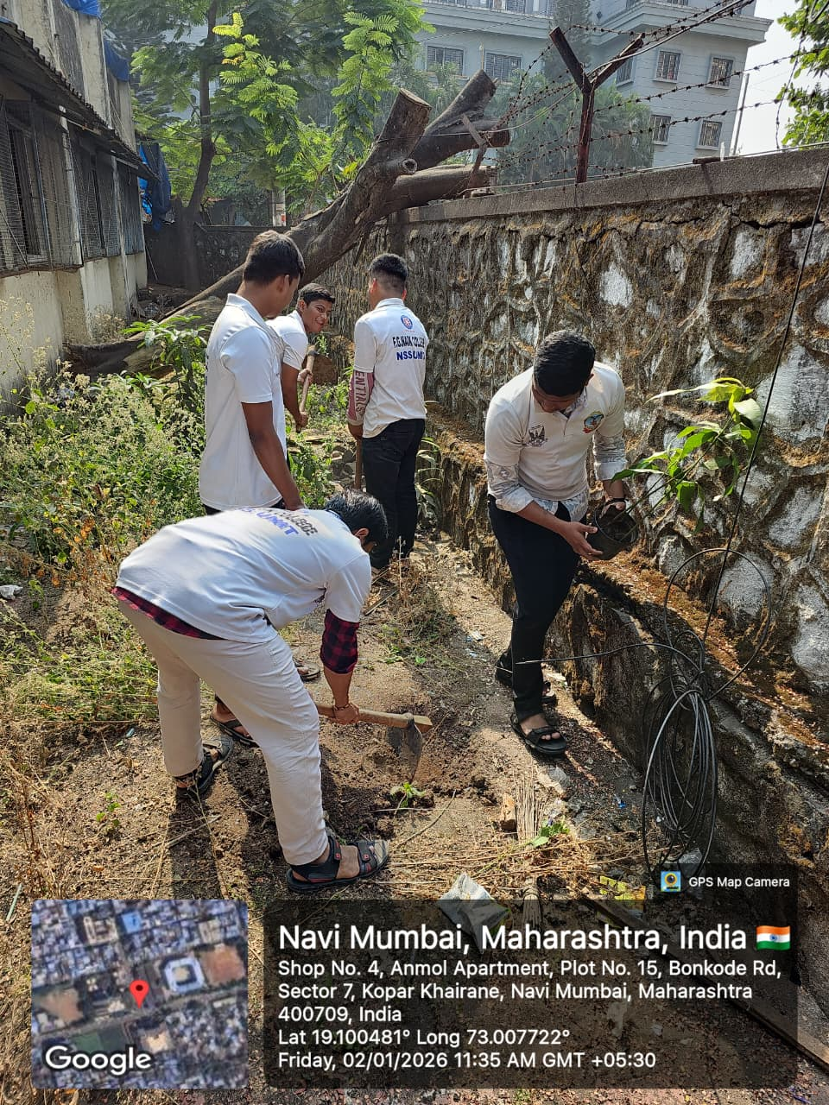

OBJECTIVE OF PROGRAM: To promote environmental awareness among students and encourage the importance of tree plantation for ecological balance, biodiversity conservation, and a sustainable future.
DATE: 02/01/2026
LOCATION: F.G Naik College
PARTICIPATING STAFF: All the NSS volunteers, teaching and the non-teaching staff of the college.
NUMBER OF VOLUNTEERS PARTICIPATING: 24
The NSS Unit organized a Tree Plantation Drive at the college campus to spread awareness about environmental protection and the importance of trees in maintaining ecological balance. The volunteers actively participated in planting saplings and learned about the role of trees in improving air quality, conserving soil, and supporting biodiversity.
The activity instilled a sense of environmental responsibility among students and motivated them to contribute towards a greener and healthier campus. The plantation drive also emphasized the need for continuous care and protection of planted saplings.
PROGRAM DETAILS: The program commenced with a brief introduction highlighting the importance of tree plantation and environmental conservation.
The NSS Unit successfully conducted the Tree Plantation program at the college campus, reinforcing the message of sustainability and collective responsibility towards nature.

NSS IQAC
PROGRAM OFFICER CO-ORRDINATOR I/C PRINCIPAL

